AWS Cloud for Data Engineering

IAM S3
1.
The initial assignment required connecting to a pre-existing AWS account via a provided SSO link and switching to a specific students-role. Because an external environment was not provided, a complete AWS infrastructure was deployed from the ground up. This configuration involved creating a primary Root account, establishing an AWS Organization, and configuring AWS IAM Identity Center to provision a secure administrative user. The resulting environment successfully replaces the missing pre-configured account.
Account Initialization and Governance Structure
To establish a foundation for the environment, a brand-new, independent AWS Root account was created through the official AWS portal by configuring primary credentials, verifying identity, and setting up the initial billing registration.

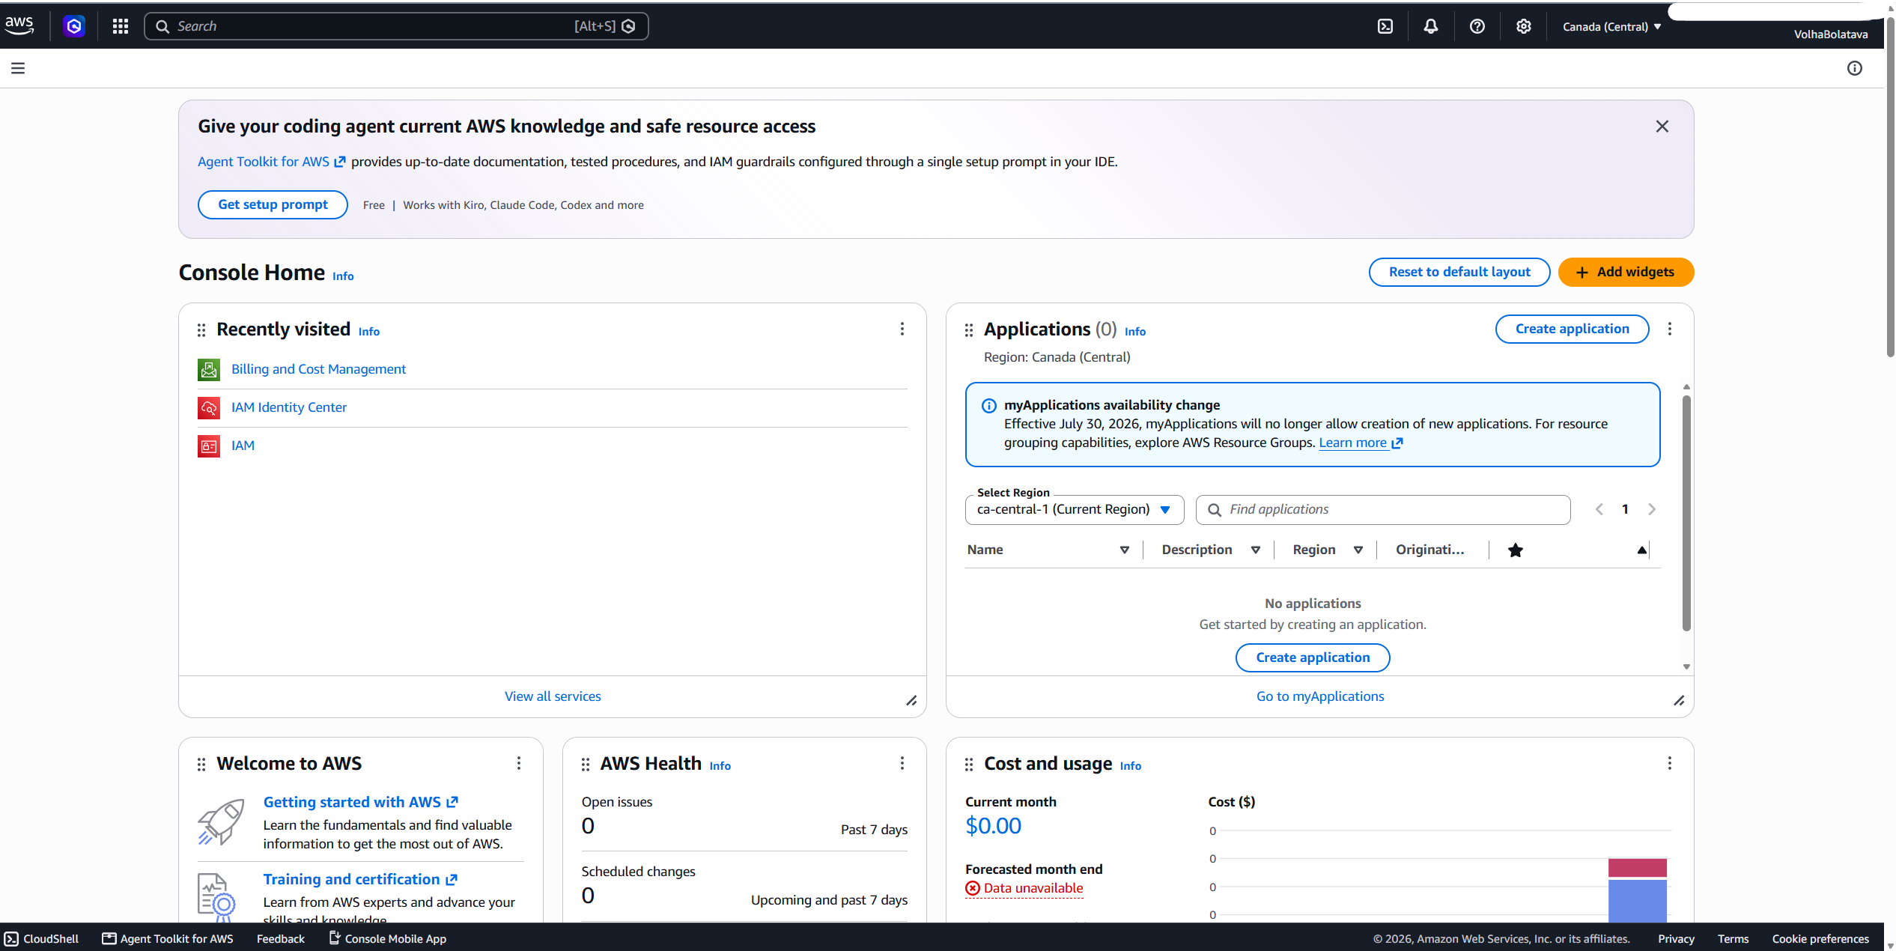

To ensure financial oversight and safeguard the newly created account against unexpected expenses, a proactive cost-tracking mechanism was deployed within the environment. Navigating to the Billing and Cost Management console under the Budgets section, a custom allocation named My Zero-Spend Budget was configured and activated. This budget was established with a strict nominal limit of $1.00, acting as a highly sensitive cost threshold.
Implementing this configuration is a critical security and operational best practice, particularly when running an independent root organization. Because cloud resources incur real-time usage charges, setting up a zero-spend budget provides an immediate early warning safety net. If any active services exceed the free tier limitations or if resources are accidentally left running, the system triggers alerts before significant financial liability occurs. The dashboard currently confirms a "Healthy" status with $0.00 consumed, validating that the environment is both cost-optimized and securely monitored against billing anomalies.
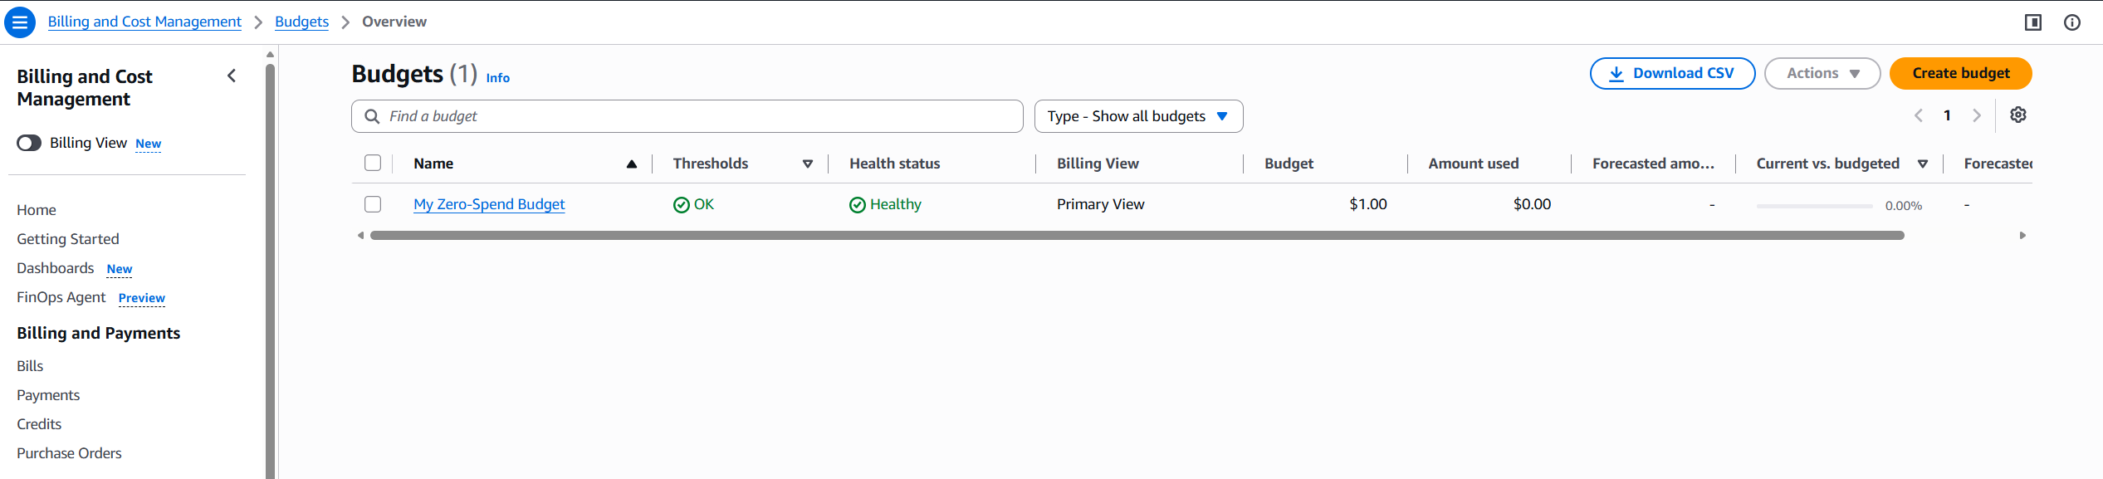

Identity Provisioning and Security Groups

Once the organizational infrastructure was active, a dedicated user group named admins was created within the Identity Center directory. Utilizing groups instead of managing individual accounts ensures scalability, allowing permissions to be modified globally and consistently across all assigned users.
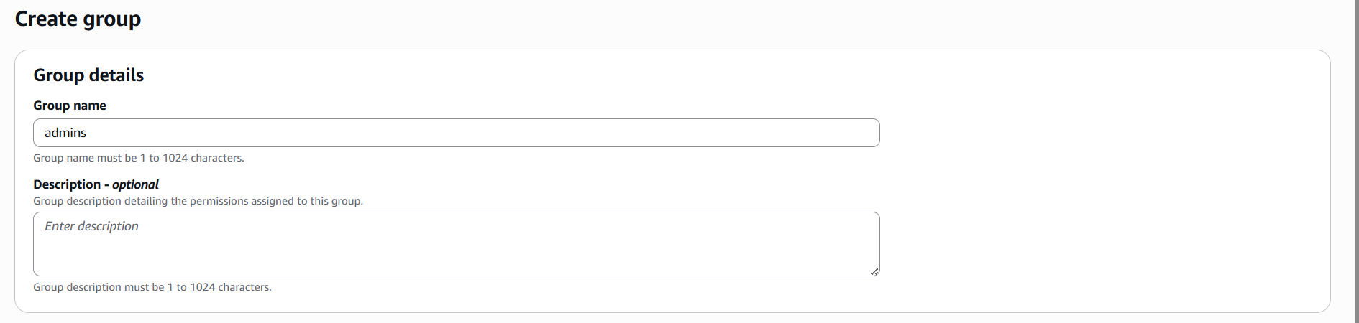
The group was created:
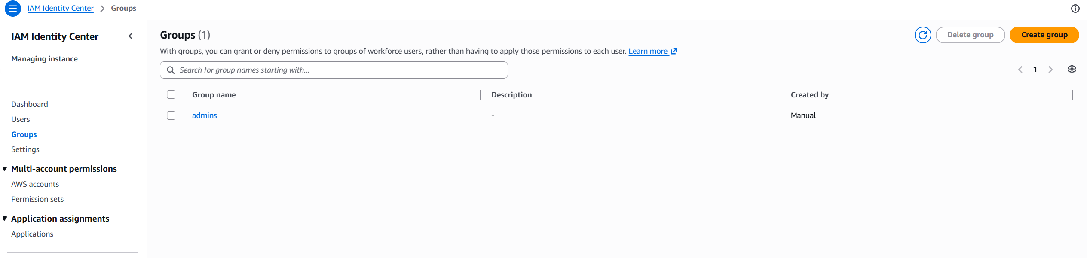
Following the group creation, a distinct IAM Identity Center user profile was provisioned with a unique username, contact email, and display metadata. This user was then explicitly assigned to the admins group. By introducing this isolated identity for daily operations, accountability is maintained through distinct audit logs, and the primary root account is completely insulated from routine configuration work.
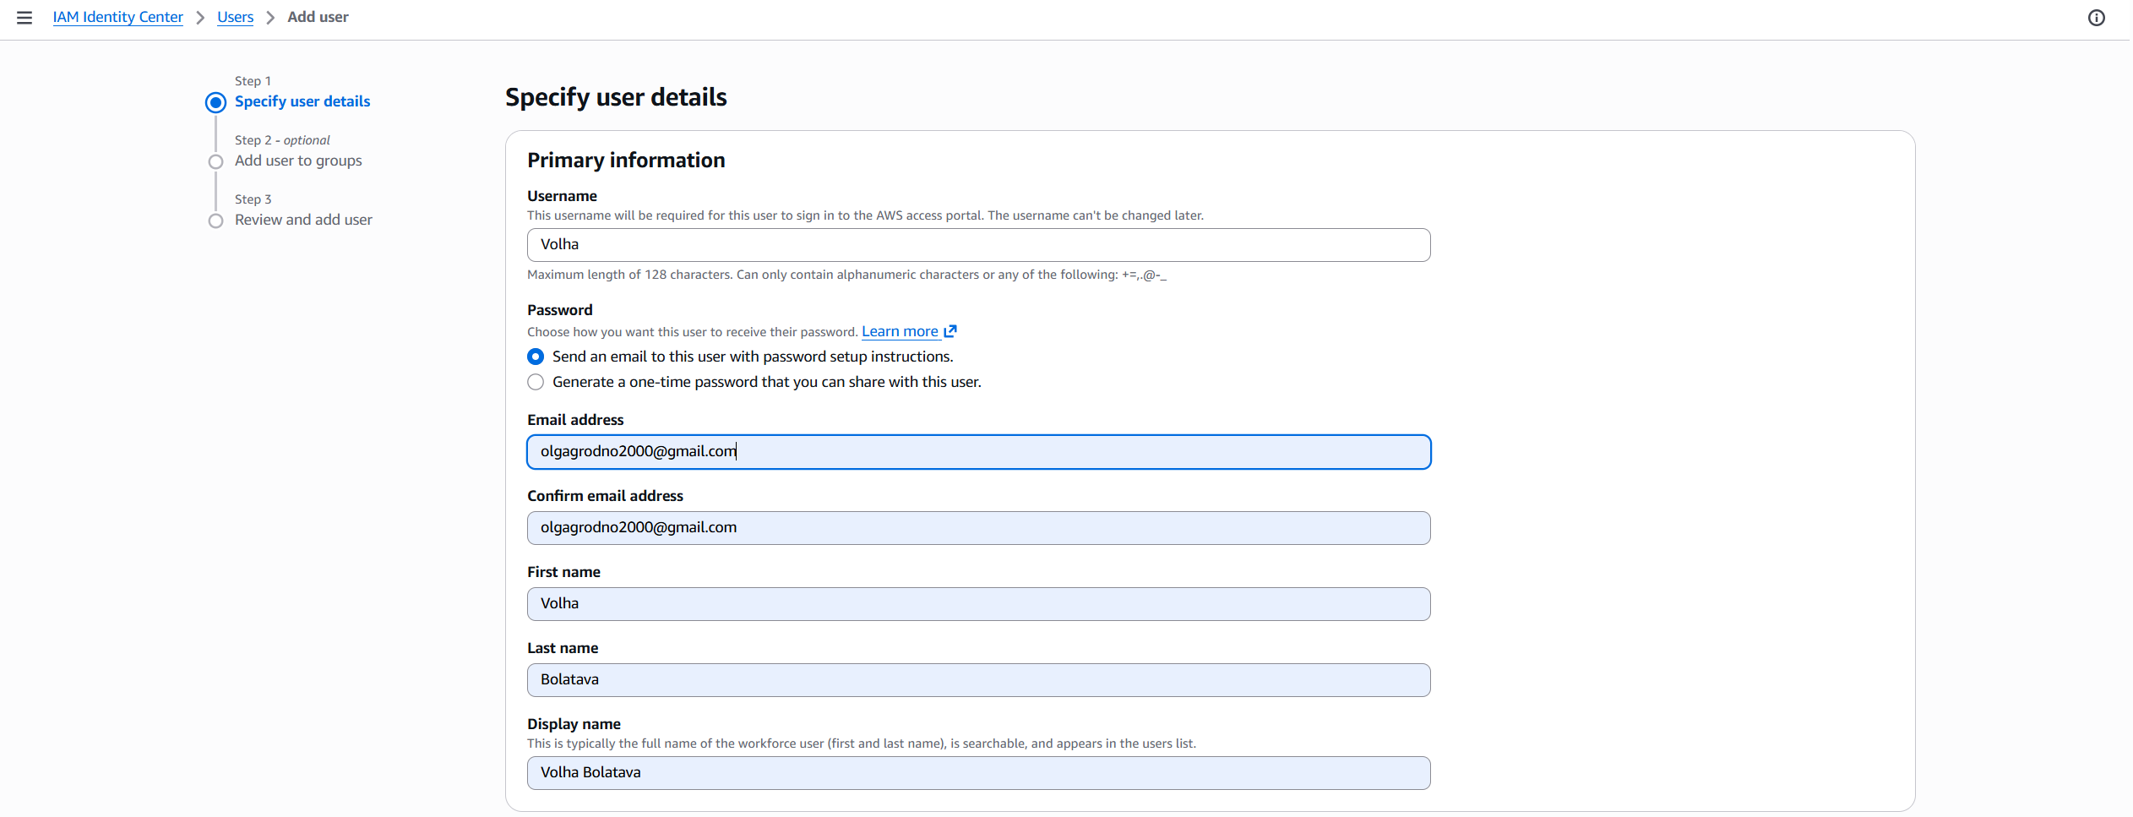
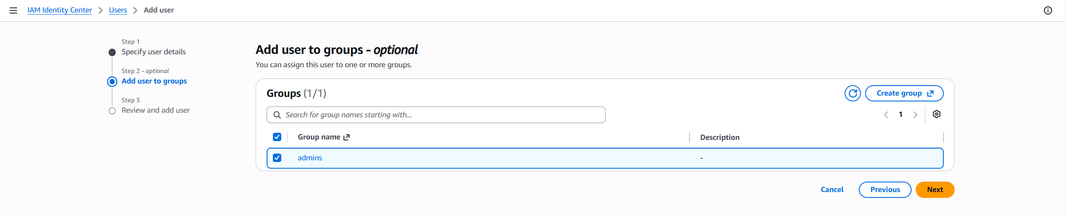
The user was created:
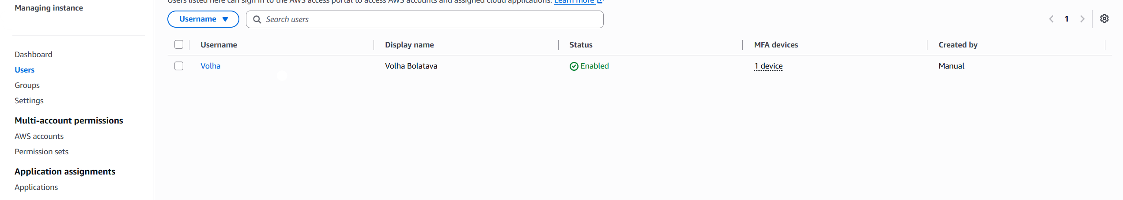
Access Control and Permission Mapping
The permission set Administrator access was created :
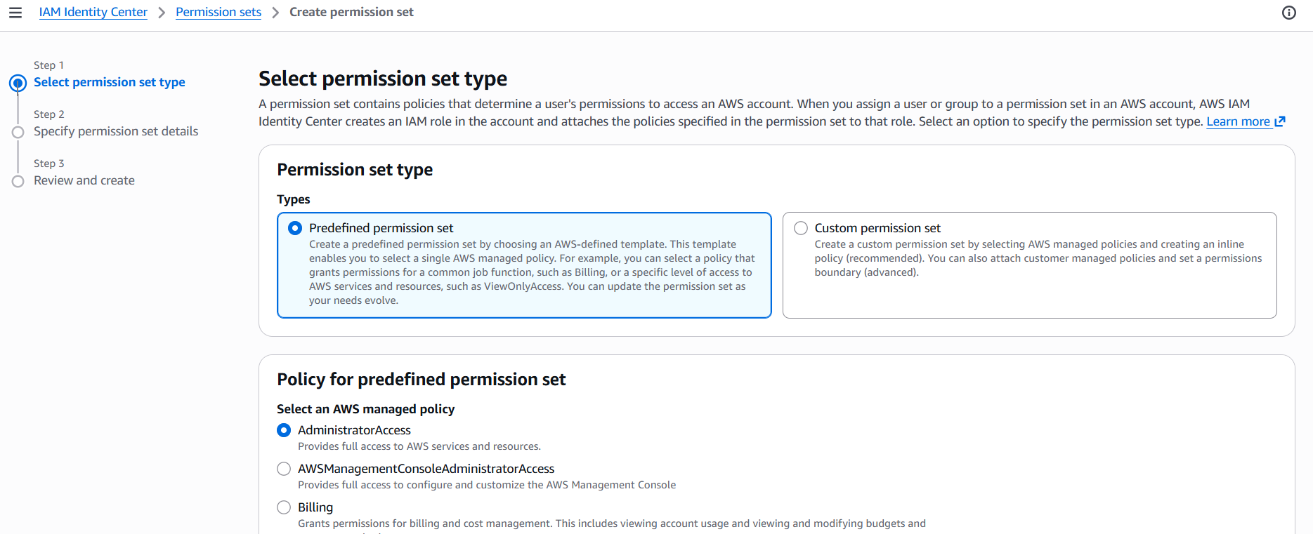
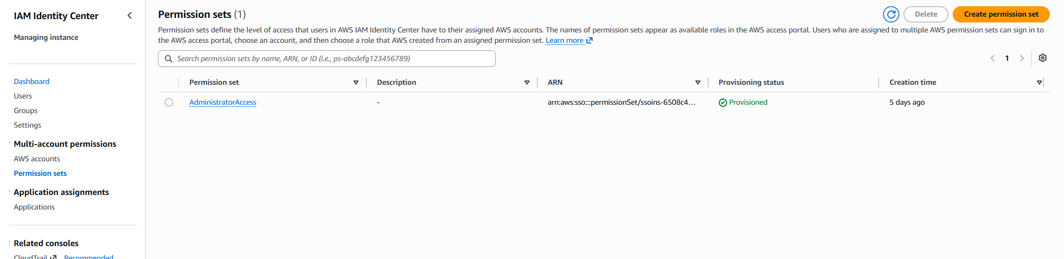
To map this new user structure to actual cloud resources, the admins group was explicitly linked to the organization's root account within the AWS accounts management tab. To define what these users could actually do, a custom permission set utilizing the predefined AWS Administrator Access policy was configured and assigned to the user.
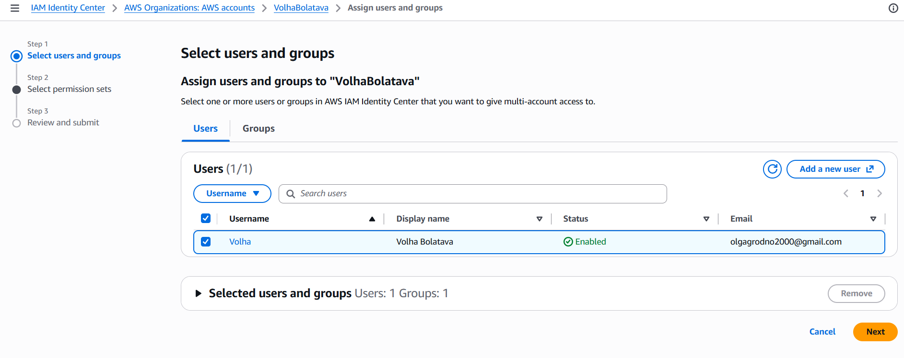
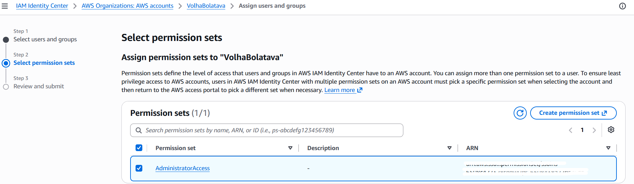
This specific configuration grants the group full operational and administrative permissions within the cloud environment. However, because it is managed through Identity Center rather than the root profile, it prevents accidental modifications to critical account-level settings and allows the access to be revoked or audited at any time.

Deployment Verification and Transition
To finalize the implementation and verify the setup, the root session was terminated by signing out of the AWS Management Console. The invitation email delivered to the new user's inbox was used to set a secure password and access the custom-generated AWS Identity Center portal URL. Logging in through this dedicated portal confirmed that the single sign-on workflow, user permissions, and group policies were fully functional, leaving the independent environment completely secure and ready for subsequent project tasks.
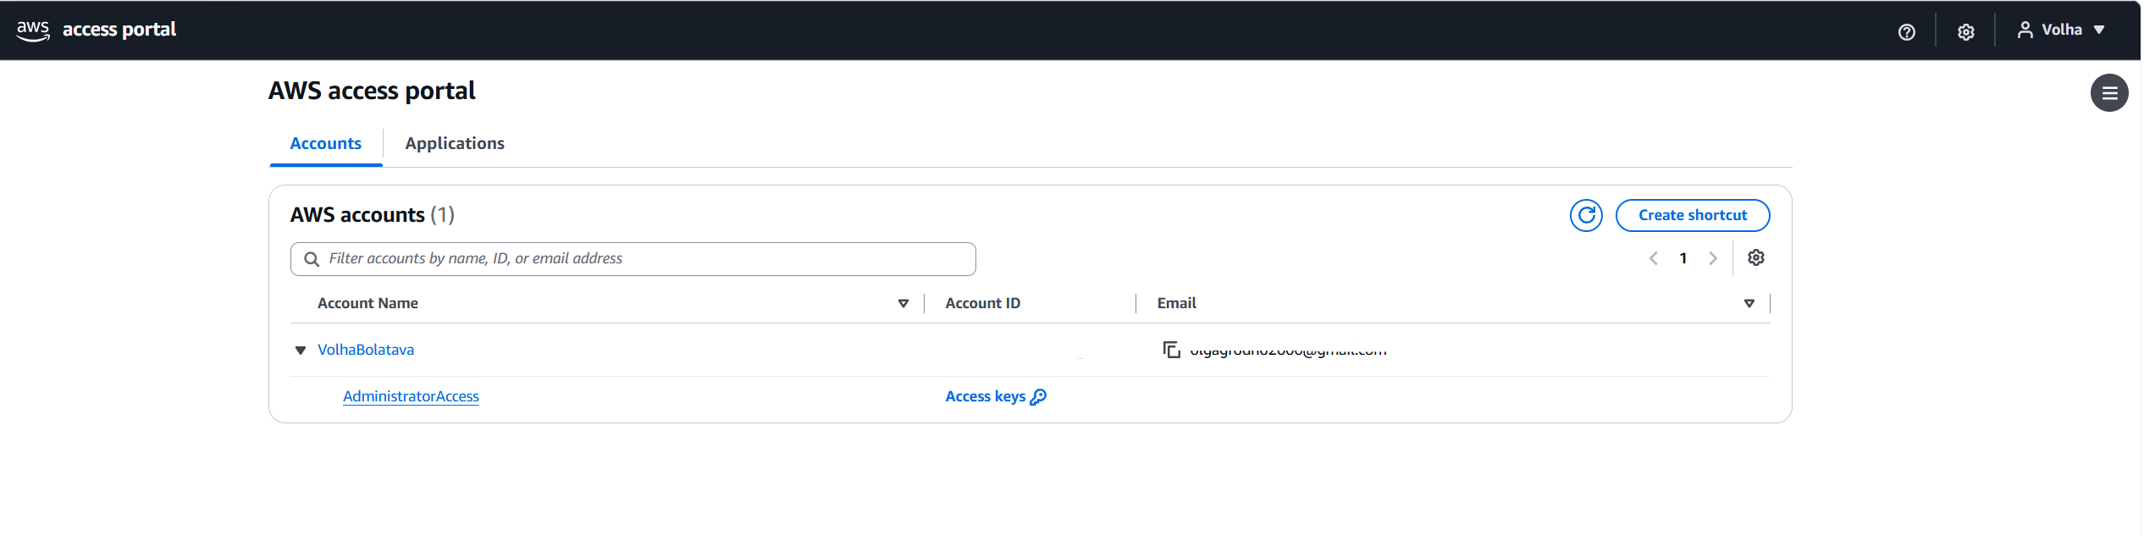
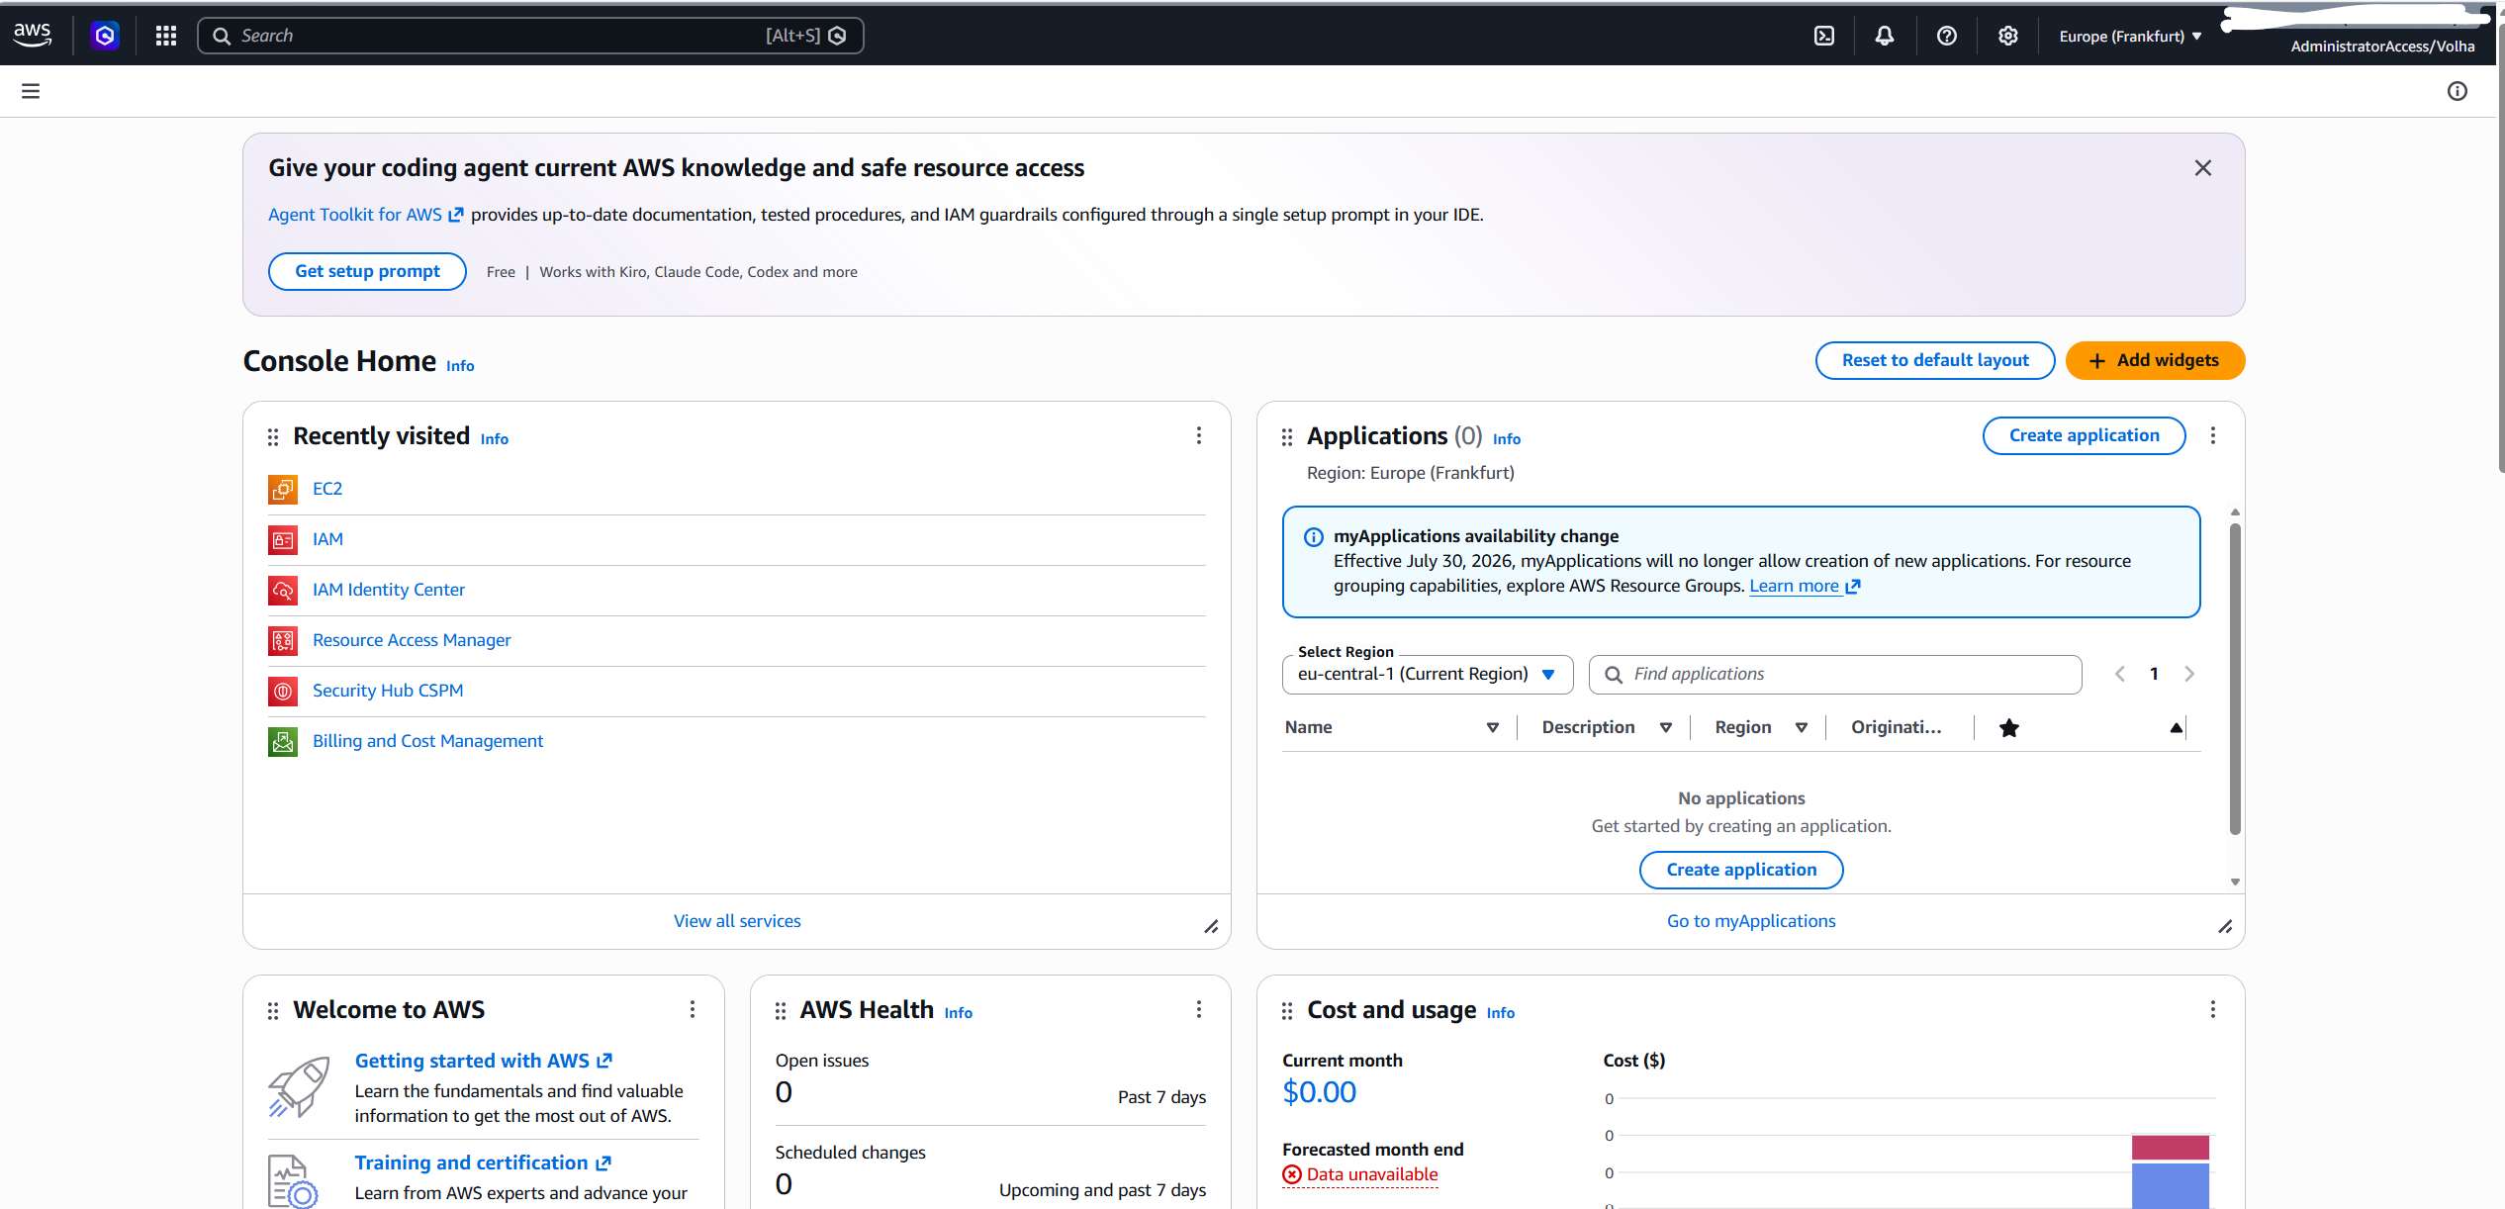

AWS CLI Installation and SSO Authentication
To enable programmatic management of cloud resources directly from the local workstation, the environment was extended to support the AWS Command Line Interface (CLI). The AWS CLI Version 2 client was downloaded and executed to complete a clean installation. Implementing this configuration is necessary to transition from graphical console management to automated, script-based infrastructure control:
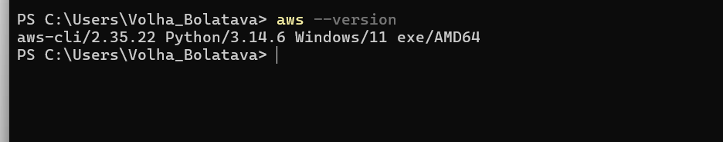

To seamlessly connect the local command-line interface with the newly configured cloud identity infrastructure, an interactive AWS Single Sign-On (SSO) configuration was executed. Executing this process enables a secure, token-based programmatic connection that completely bypasses the need for long-term static passwords or manual copy-pasting of short-term access tokens. The custom AWS Identity Center URL and the regional hub designation (eu-north-1) were supplied to the prompt. This action automatically launched an external browser session, requesting secure authentication verification. Once the login prompt was confirmed in the browser, the remote security token was securely shared with the local machine, establishing a reliable, short-term authorization window.
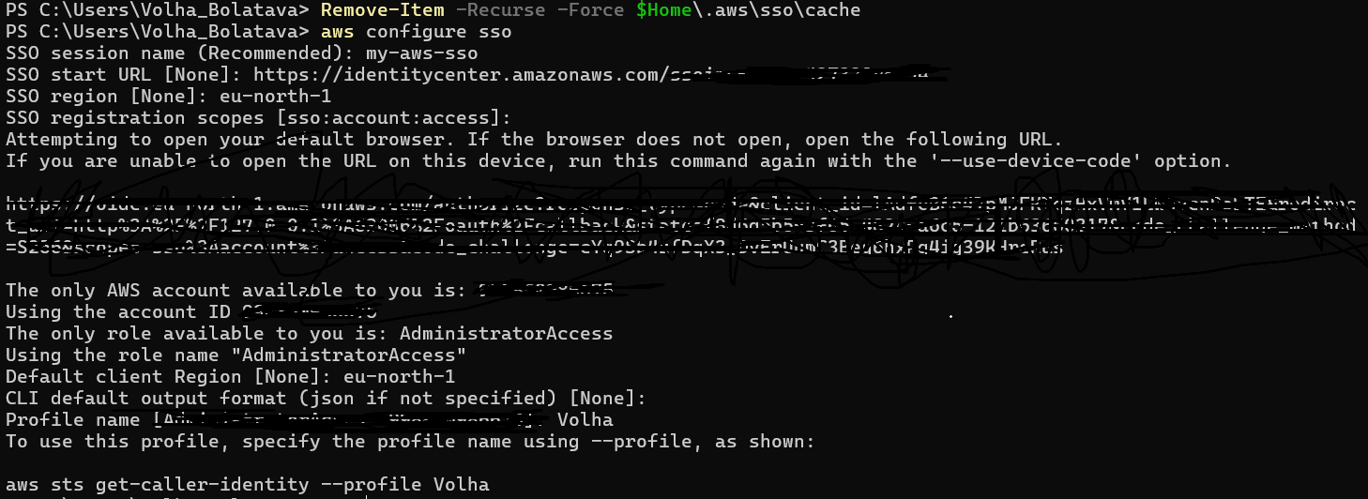
Upon successful browser verification, the local client automatically mapped the discovered cloud account and its administrative permissions to a custom local profile, ensuring that all subsequent terminal commands and deployment scripts securely target the correct isolated environment by default.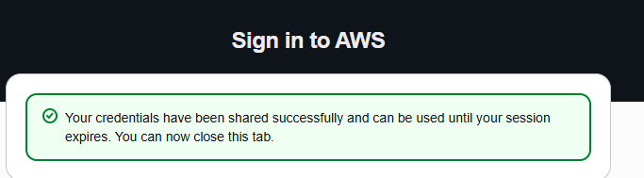
Following the successful authentication process, the configuration was verified by opening the local AWS config file, confirming that the AWS CLI had accurately written the programmatic single sign-on parameters—including the SSO start URL, regional routing settings, and your designated local profile name—into the system's permanent configuration repository.

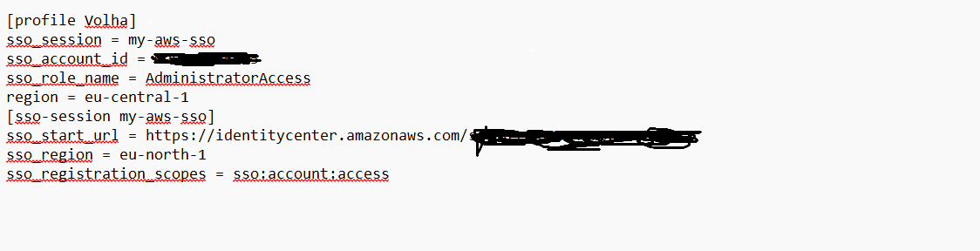

Following the confirmation of the local configuration parameters, the active connection was validated by executing the identity lookup command aws sts get-caller-identity --profile Volha within the terminal. Running this command invokes the AWS Security Token Service (STS) to query the current operational context of the active profile. The successful output returned the distinct User ID, the root organization's account number, and the assumed administrative role ARN, definitively proving that the local terminal is successfully authenticated and possesses the required cloud permissions to execute subsequent project tasks.
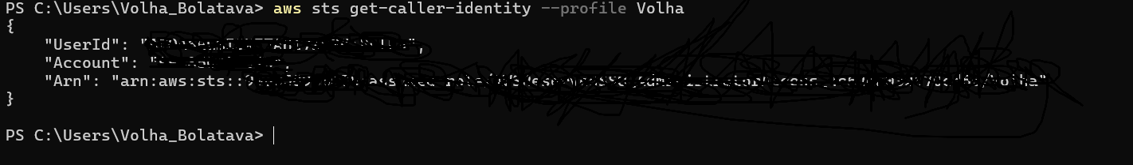

2.

To create a safe and reliable storage space for project data, a new bucket was created inside the Amazon S3 console.

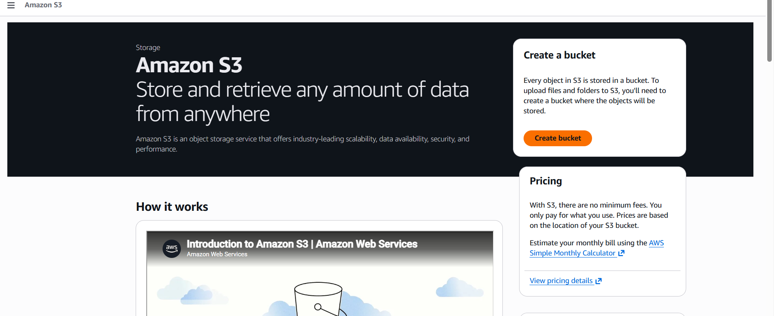
To keep things fast and cost-effective, the storage was placed in the closest region (eu-central-1) and set up as a standard General Purpose container. To make sure this folder could be easily found in the cloud, it was given the unique name s3bucketvolha.

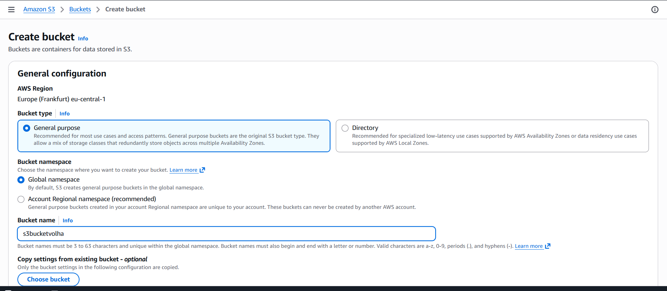
This setup gives a secure, ready-to-use landing zone for all data files. Because it is a cloud-based storage, there is no need to worry about running out of space, and it can be easily connected to other AWS services for scanning, querying, or auditing the files at any time.
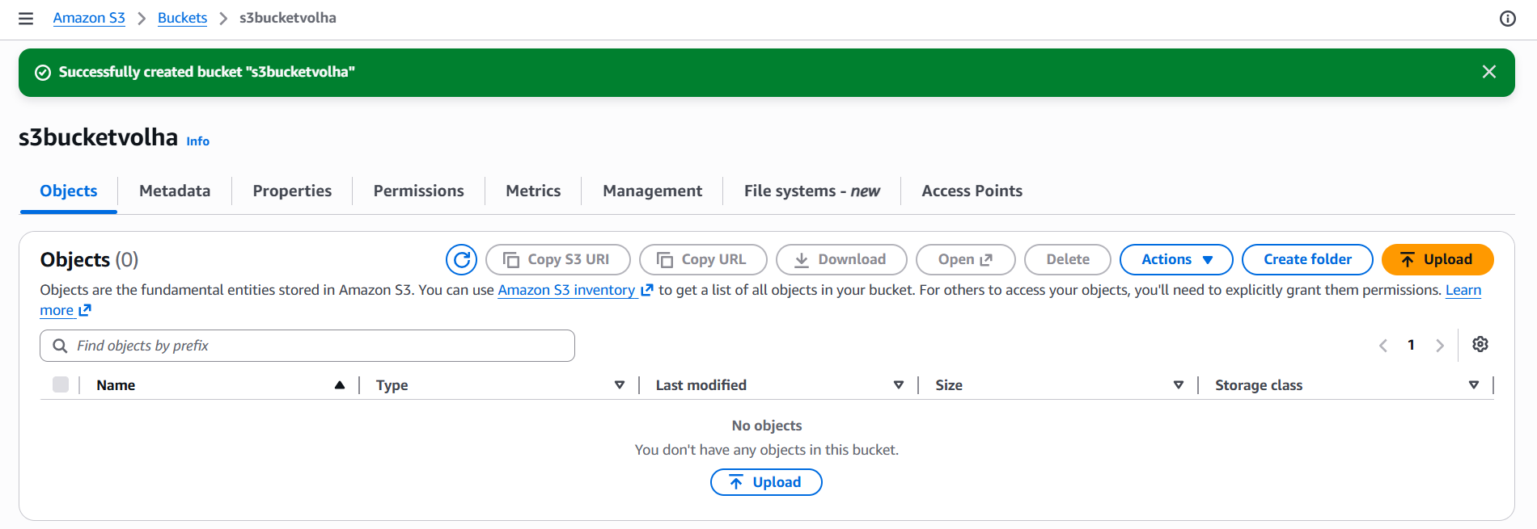
To organize the raw analytical data before running any queries, a clear folder hierarchy was created directly inside the s3bucketvolha bucket using the AWS Management Console. First, a root folder named dwh_database was created. 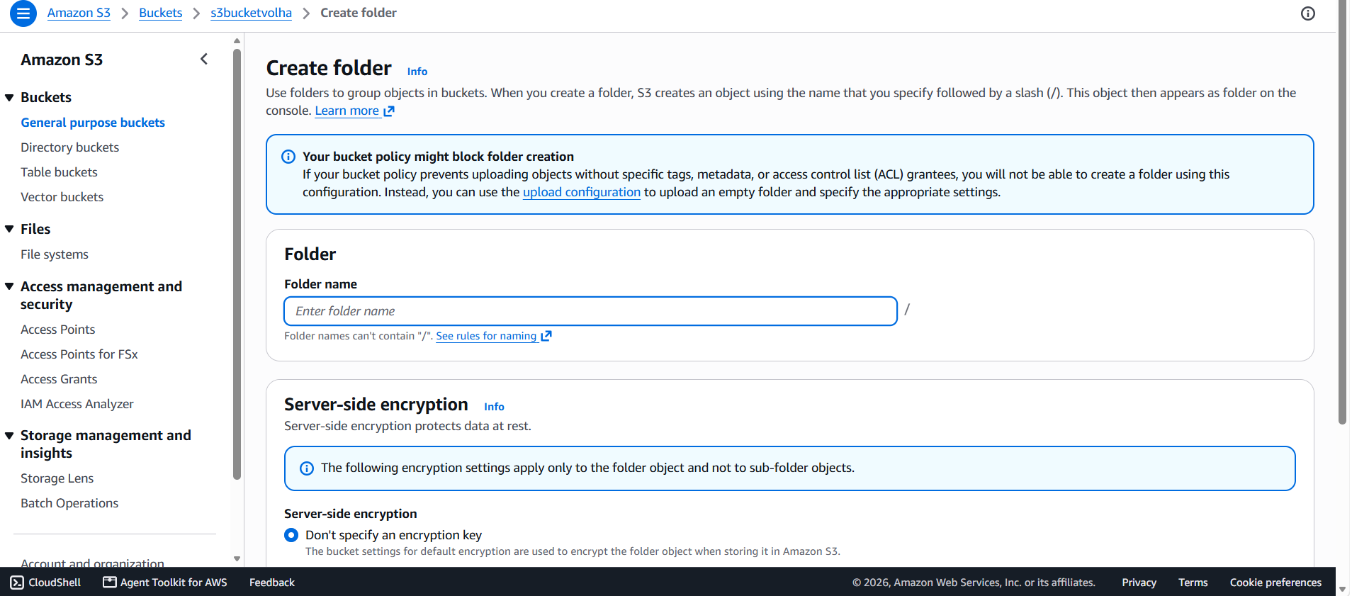
Inside this root directory, a schema folder called bl_dm was set up to represent the business logic data mart layer.
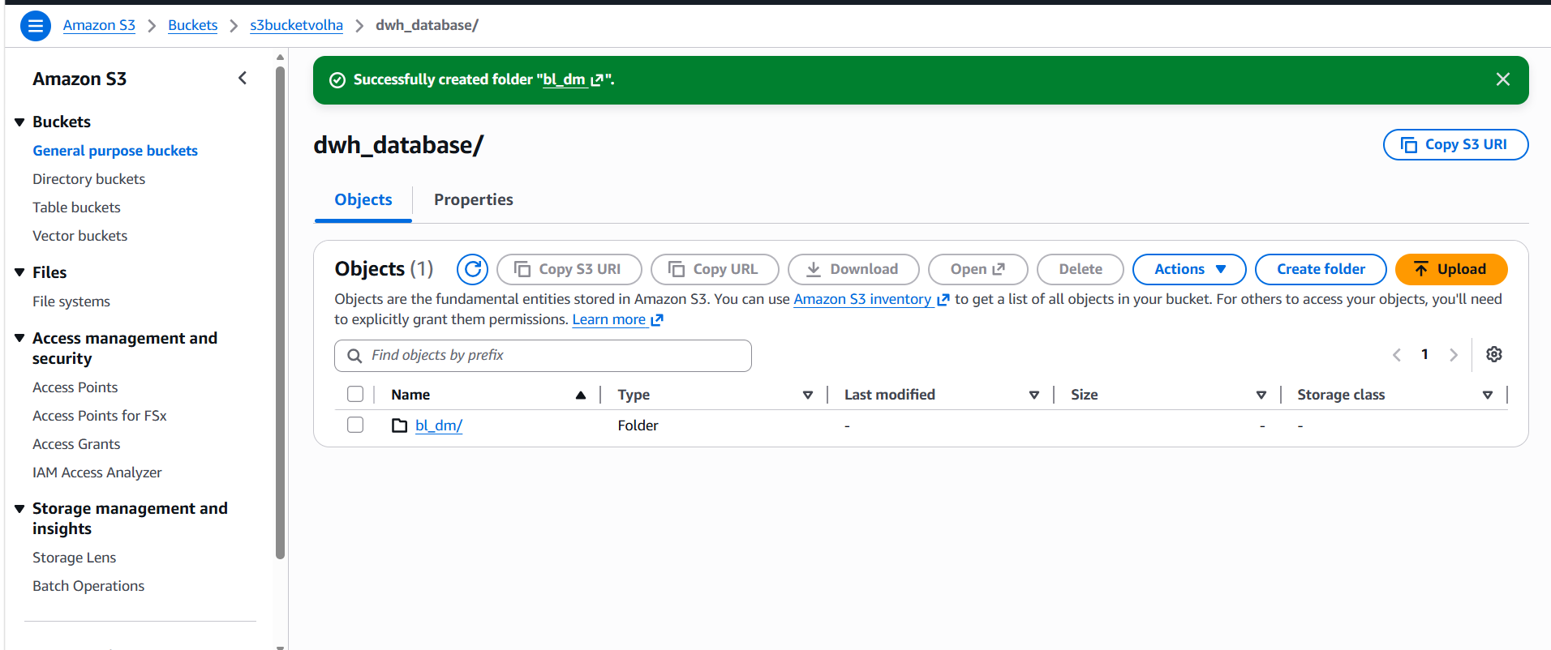
Finally, to separate the data files for individual database tables, six dedicated sub-folders were created inside the bl_dm directory, using the exact names from the database system:
- dim_dates_day
- dim_vendors
- dim_promotions
- dim_stores
- dim_items_scd
- fct_sales_dd
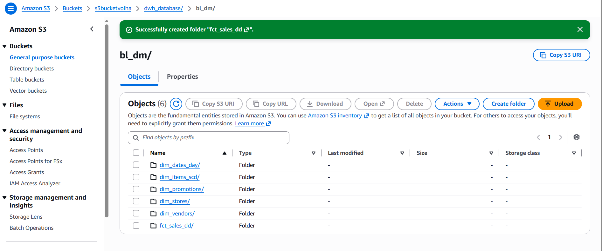
This structured layout acts as a neat, ready-to-use folder system for the Data Lake. Because the folders are named exactly like the future database tables, it allows AWS Glue to automatically scan the files, recognize the schema, and map the data without any manual naming confusion later on.

To upload the local data files into the newly created folder hierarchy, specific AWS Command Line Interface (CLI) sync operations were executed using the aws s3 cp command. This step pushes each individual dataset from the local storage environment directly into its dedicated cloud partition. The following commands were used to execute the data upload:

aws s3 cp C:\Users\Volha_Bolatava\PycharmProjects\AWS\dim_dates_day.csv s3://s3bucketvolha/dwh_database/bl_dm/dim_dates_day/dim_dates_day.csv --profile Volha
aws s3 cp C:\Users\Volha_Bolatava\PycharmProjects\AWS\dim_items_scd.csv s3://s3bucketvolha/dwh_database/bl_dm/dim_items_scd/dim_items_scd.csv --profile Volha
aws s3 cp C:\Users\Volha_Bolatava\PycharmProjects\AWS\dim_promotions.csv s3://s3bucketvolha/dwh_database/bl_dm/dim_promotions/dim_promotions.csv --profile Volha
aws s3 cp C:\Users\Volha_Bolatava\PycharmProjects\AWS\dim_stores.csv s3://s3bucketvolha/dwh_database/bl_dm/dim_stores/dim_stores.csv --profile Volha
aws s3 cp C:\Users\Volha_Bolatava\PycharmProjects\AWS\dim_vendors.csv s3://s3bucketvolha/dwh_database/bl_dm/dim_vendors/dim_vendors.csv --profile Volha
aws s3 cp C:\Users\Volha_Bolatava\PycharmProjects\AWS\fct_sales_dd.csv s3://s3bucketvolha/dwh_database/bl_dm/fct_sales_dd/fct_sales_dd.csv --profile Volha

Each local CSV file is securely mapped to its corresponding sub-folder inside the Amazon S3 bucket, ensuring that dimensions and facts remain isolated:

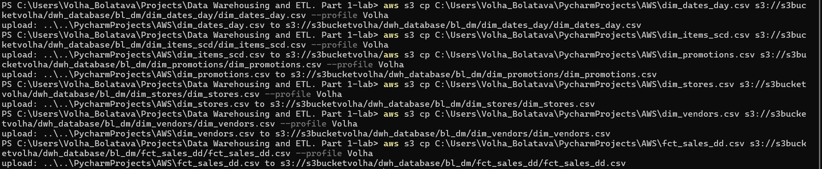
To automatically scan the uploaded CSV files and map them into actual database tables, an automated data discovery worker (Crawler) was configured inside the AWS Glue console.
Basic identity tracking parameters were established in the initial settings screen. To make the worker easily identifiable, the unique name crawler_bl_dm_volha was supplied to the system. Additionally, under the optional tracking settings, a resource identifier tag was assigned with the key set to owner and the value set to student to maintain organized resource ownership.

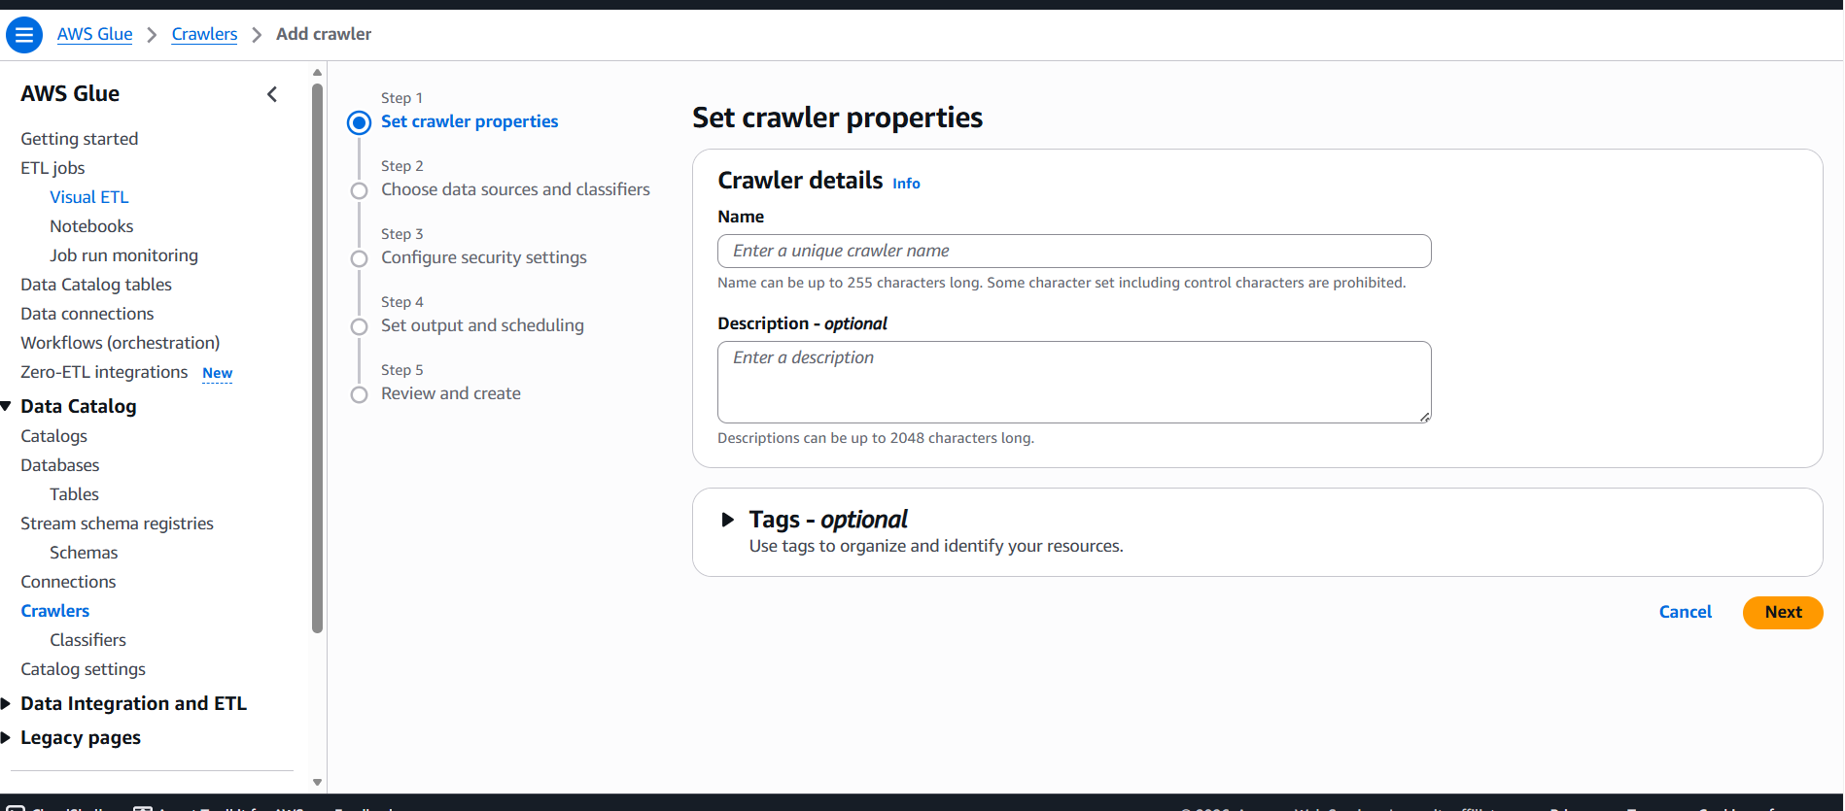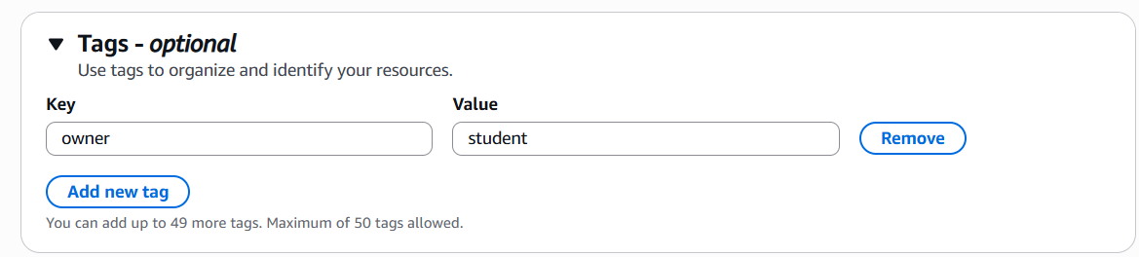
To point the crawler to the exact location of the raw files, the data source type was explicitly set to S3. Within the network and location configurations, the source target path was directed to the pre-existing folder layer in the current account: s3://s3bucketvolha/dwh_database/bl_dm/. The running option was set to Crawl all sub-folders, allowing a single pass to scan all six table folders at the same time.
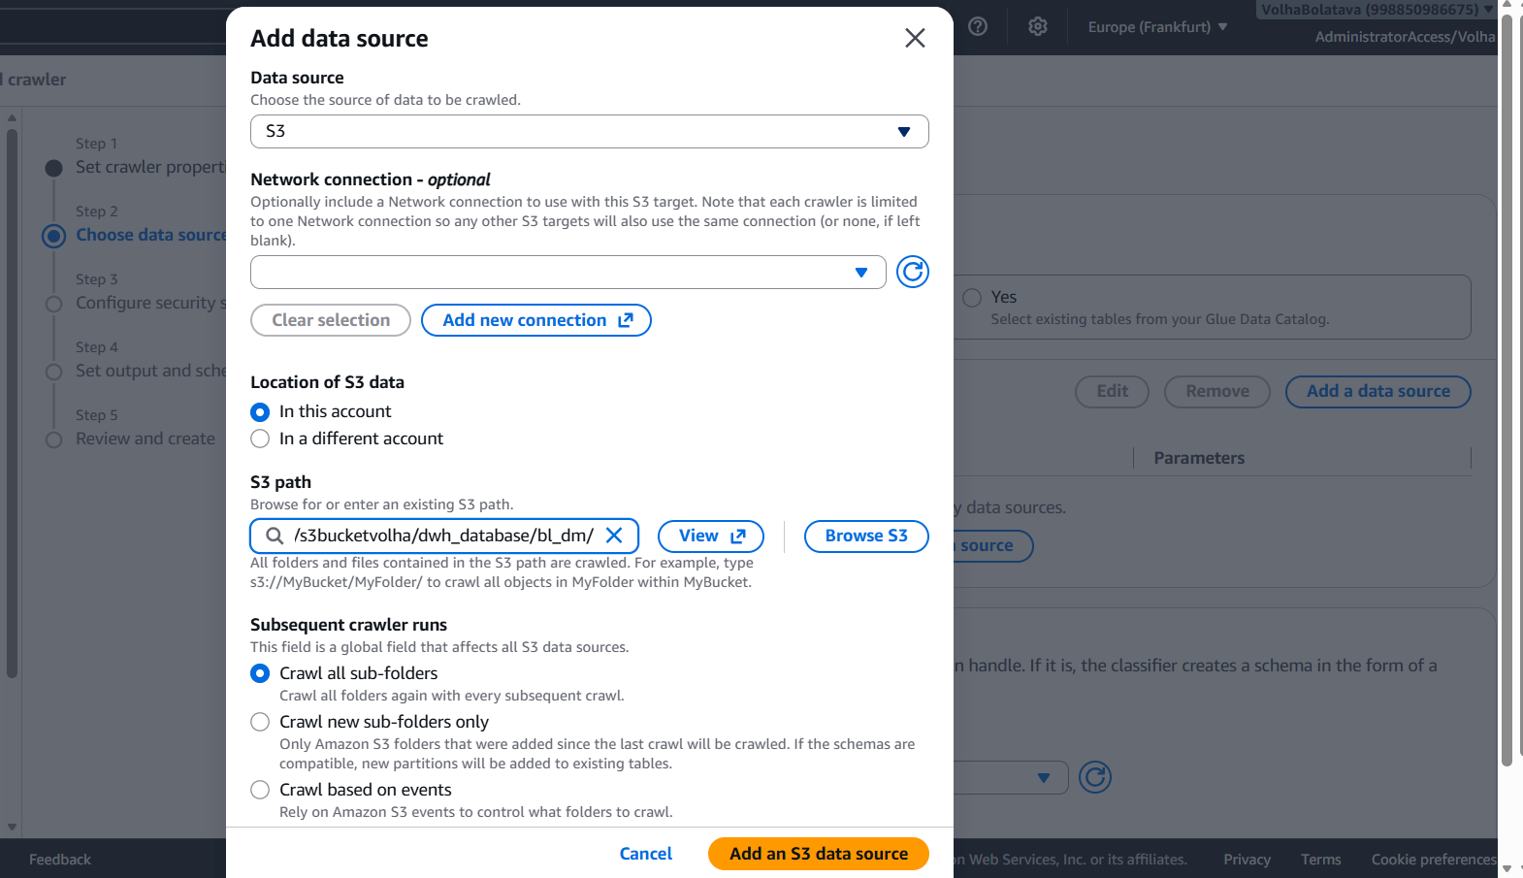
To give AWS Glue permission to read the files, a secure connection profile was generated. A new dedicated IAM security role named AWSGlueServiceRole-crawler-s3-access was created and linked directly to the crawler workflow. This specific configuration grants the crawler full permission to read the files inside the S3 bucket safely without exposing any other cloud infrastructure settings.
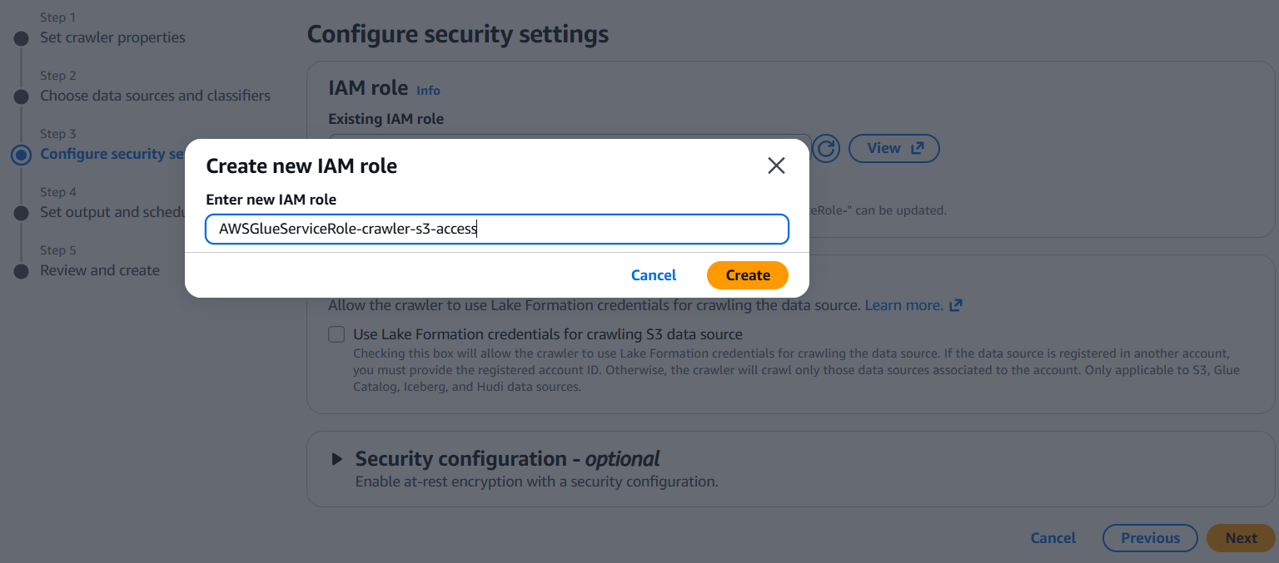
To control where the final metadata tables land, the target destination database was selected from the dropdown menu as db_bl_dm. To run the schema sync dynamically instead of relying on a rigid automated timer, the execution frequency was set to On demand, ensuring full control over when data scans happen.
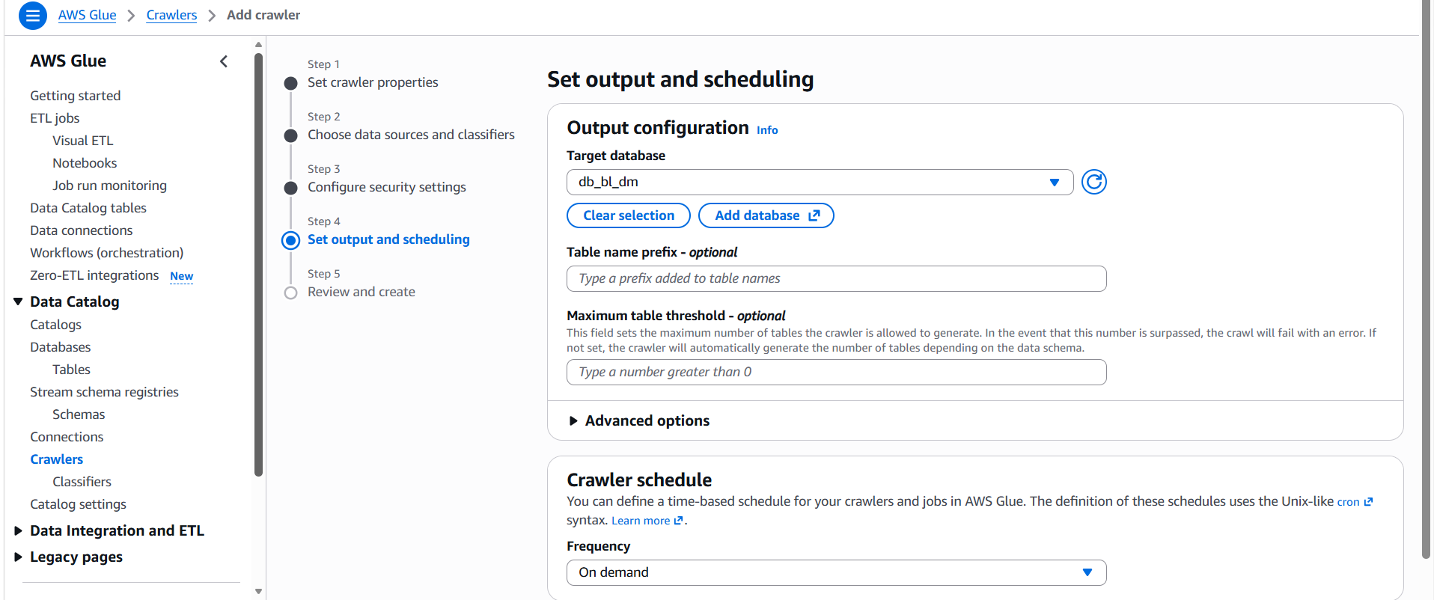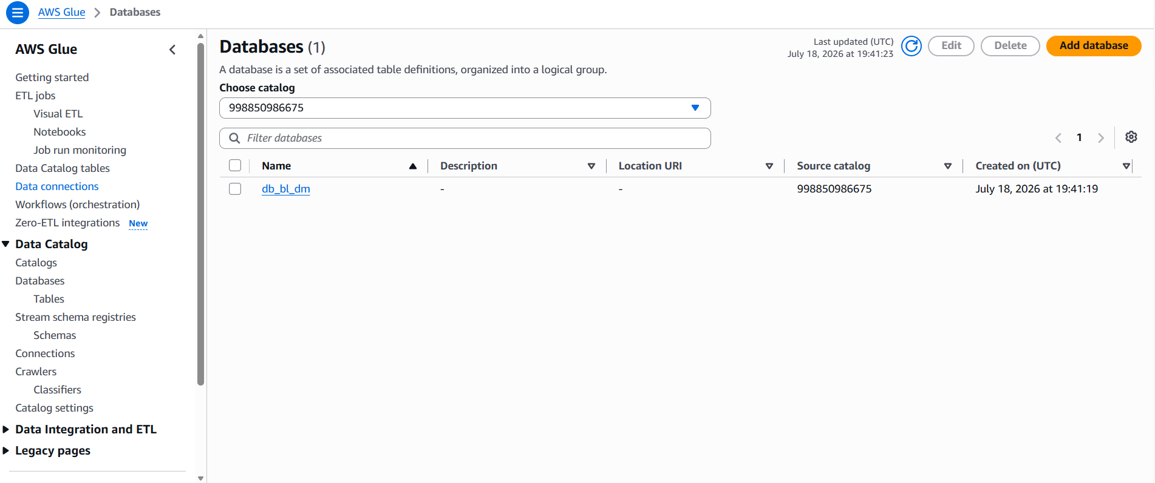
Upon finalizing the creation steps, the screen confirmed the workflow with a green status message: "One crawler successfully created".
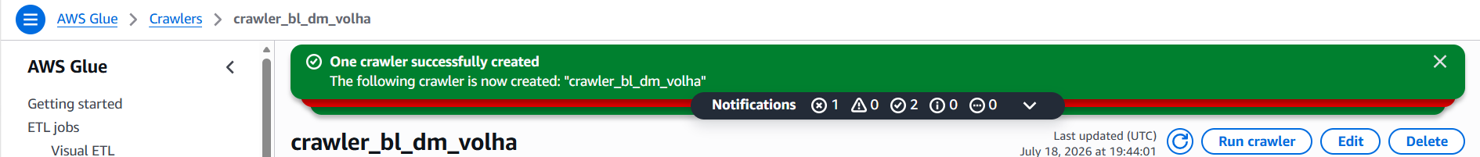
The crawler was successfully created:
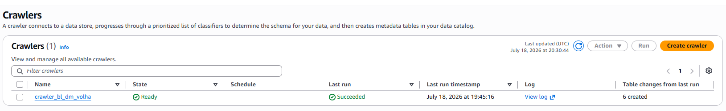
The processing was immediately initiated using the Run crawler action button:

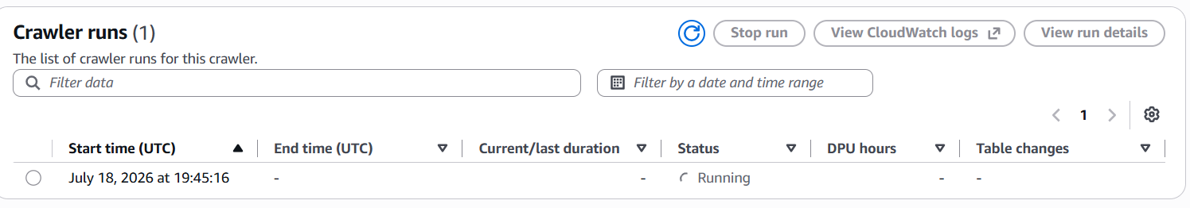
The job moved directly into the Running phase, and within exactly 36 seconds, the job status changed to Completed. The structural results showed a successful run with 6 table changes logged.
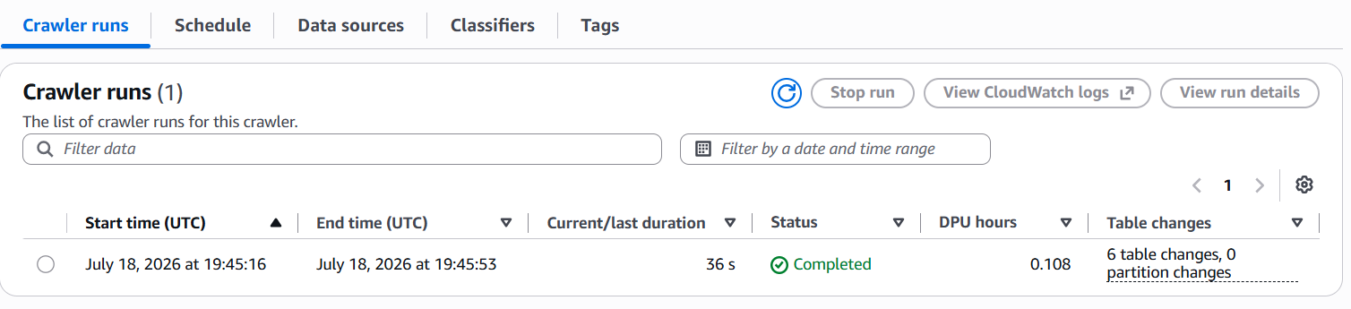
Navigating directly to the AWS Glue Data Catalog tables ledger verifies that all six tables (dim_dates_day, dim_items_scd, dim_promotions, dim_stores, dim_vendors, and fct_sales_dd) are now fully registered as clean CSV classifications, completely ready for analytical SQL querying.
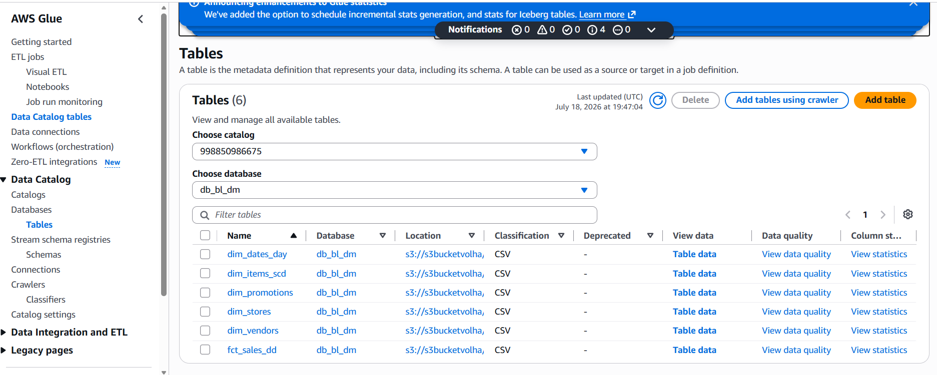
To run ad-hoc SQL queries directly against the Data Lake without deploying a traditional database server, the environment was configured within the Amazon Athena console. This setup ensures that query outputs are properly stored and validated against the AWS Glue Data Catalog.
Before running any code, the query execution environment required a dedicated location to save execution history and temporary files. Navigating to the Query settings tab inside the Athena Query editor showed that no output directory or encryption parameters were assigned by default. To resolve this, the Manage trigger was engaged to configure the required location properties.

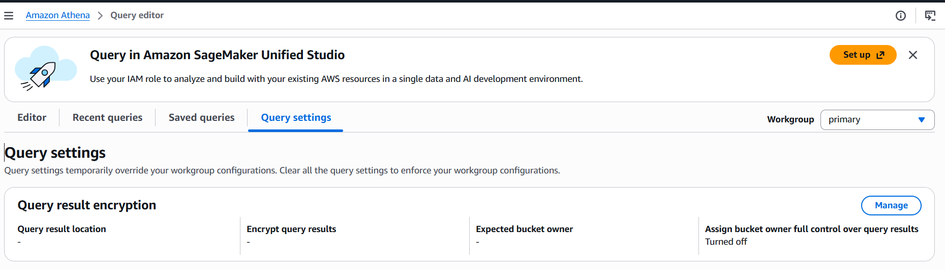
Within the Manage query result location and encryption configuration window, an explicit destination path was designated for all future outputs. The location was pointed directly to a new sub-folder inside the main project storage container: s3://s3bucketvolha/athena-results/. Assigning this dedicated S3 prefix ensures that any compiled CSV query results or metadata logs are safely isolated from the core data mart directories.
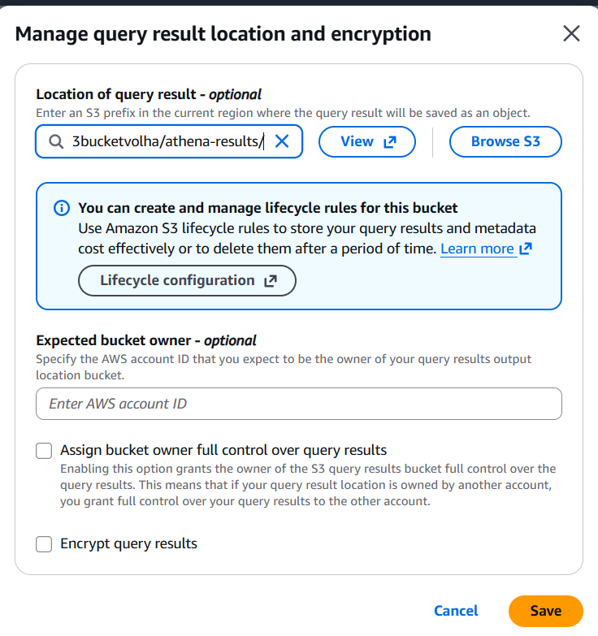
Once the storage settings were saved, the interface was switched back to the main Editor tab. To expose the correct data structures to the query window, the environment parameters on the left navigation panel were set to use the AwsDataCatalog data source and the target db_bl_dm database. This immediately loaded all six scanned tables into the active view pane.
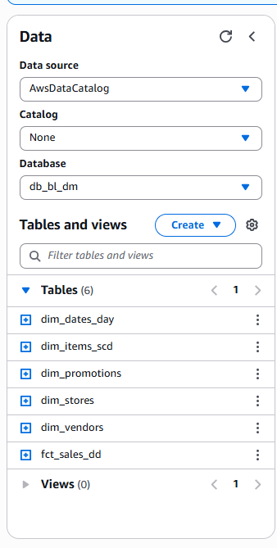
The analytical query was then executed to calculate total sales and revenue by store and vendor:

SELECT
s.store_name,
v.vendor_name,
COUNT(f.store_surr_id) AS total_sales_count,
SUM(f.fct_sale_amt_usd) AS total_revenue
FROM
fct_sales_dd f
JOIN
dim_stores s ON f.store_surr_id = s.store_surr_id
JOIN
dim_vendors v ON f.vendor_surr_id = v.vendor_surr_id
GROUP BY
s.store_name, v.vendor_name
ORDER BY
total_revenue DESC;

The execution engine completed the operation successfully, returning a green Completed status.
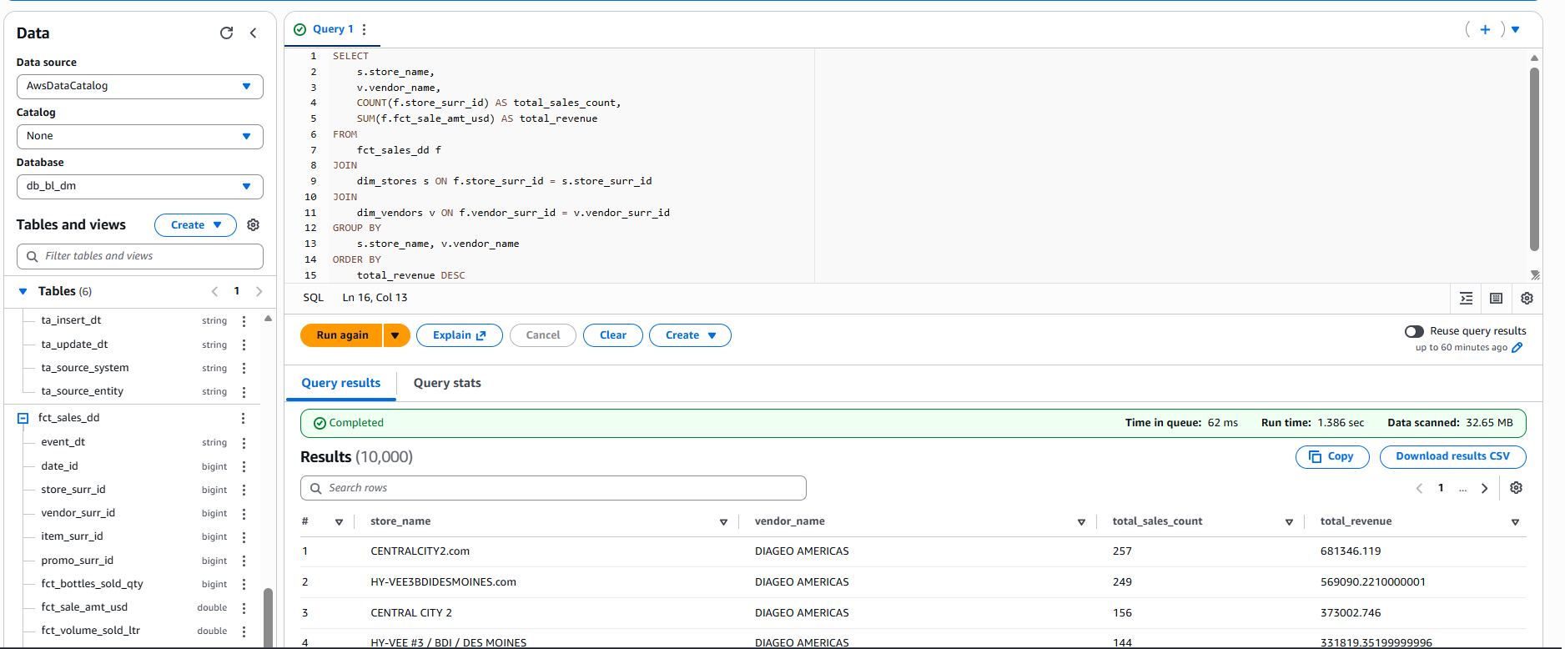
The clean tabular results immediately displayed top-performing business entries—such as CENTRALCITY2.com and DIAGEO AMERICAS generating over $681,346 in revenue—confirming that the serverless cloud warehouse is fully operational, correctly integrated, and processing queries with optimal performance.

